1-6 Ordered Pairs and Relations

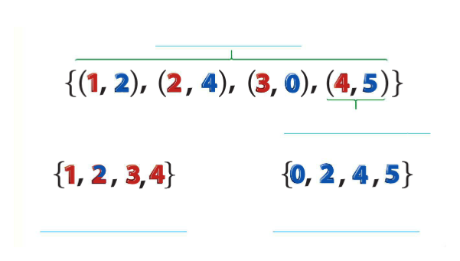
A set of ordered pairs such as {(1,2) (2,4) (3,0) (4,5)} is a RELATION. The DOMAIN of the relation is the set of x-coordinates. The RANGE of the relation is the set of y-coordinates.

Label the set to the right with
the terms domain, ordered pair,
range, and relation.

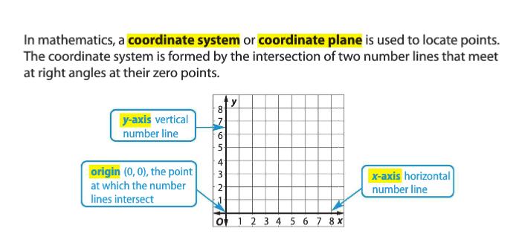

Graph the points: (3,4), (8,6), (4,3)

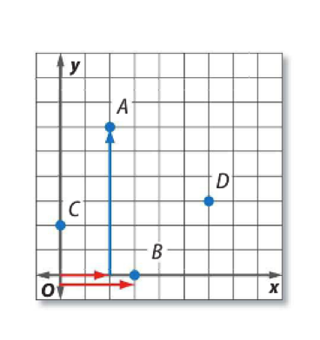

Write the ordered pair that names each point:

A C

B D

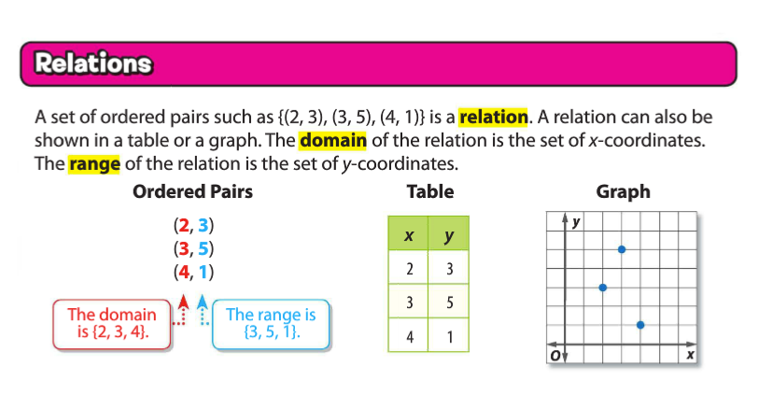

A seahorse swims at a rate of about 5 feet per hour.

A) Make a table of ordered pairs in which the x-coordinate represents the hours and the y-coordinate represents the number of feet for 1, 2, and 4 hours.
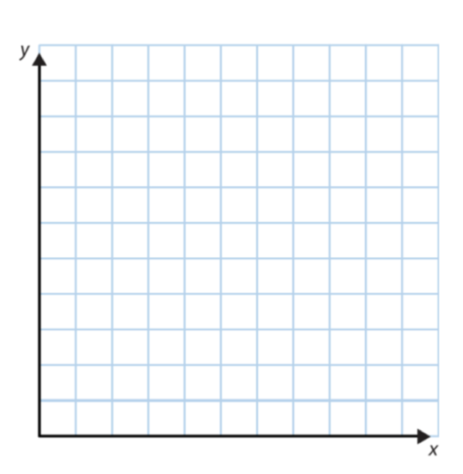
B) Graph the ordered pairs and describe the graph.

Mrs. Drown is hiking in a state park. She averages 3 miles per hour.

A) Make a table of ordered pairs in which the x-coordinate represents the number of hours and the y-coordinate represents the number of miles hiked in 1,2,4, and 6 hours.

B) Graph the ordered pairs.

